[One time setup] Install IPython
From the top left menu, Open a terminal: Applications => System Tools => Terminal
Type:
sudo easy_install ipython==1.2.1
Hit enter, administrator password is cloudera.

Launch pyspark with IPython
Every time you need to open the pyspark shell, open a terminal and type:
PYSPARK_DRIVER_PYTHON=ipython pyspark
Hit enter, after the startup logs, you should see the pyspark console:
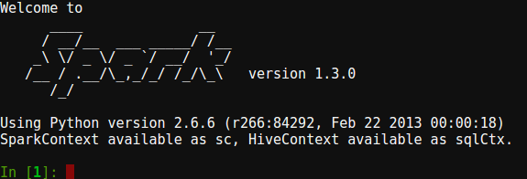

Check version
To make sure that PySpark started correctly, print out the version by typing in the PySpark IPython terminal:
sc.version
Verify that the output is:
u'1.3.0'

Python resources
This module requires a basic knowledge of Python to perform the programming assignments.
I recommend to take the interactive tutorial at: http://learnpython.org, the "Learn the basics" section should be enough.
Then if you want to learn more about Python, even if not necessary for this class, you can check the Coursera class:
https://www.coursera.org/learn/python

